My Recipe page Design document

## 

## My recipes page

When user is successfully login to the website he/she is able see My Recipes Page. On the screen the user can see all of recipes which he/she made. On the top of the screen user is able to see navigation menu bar with 6 buttons – HOMEPAGE, ABOUT, NEW RECIPES, MY RECIPES, PROFILE, LOGOUT – and the websites logo.

## URL diagram

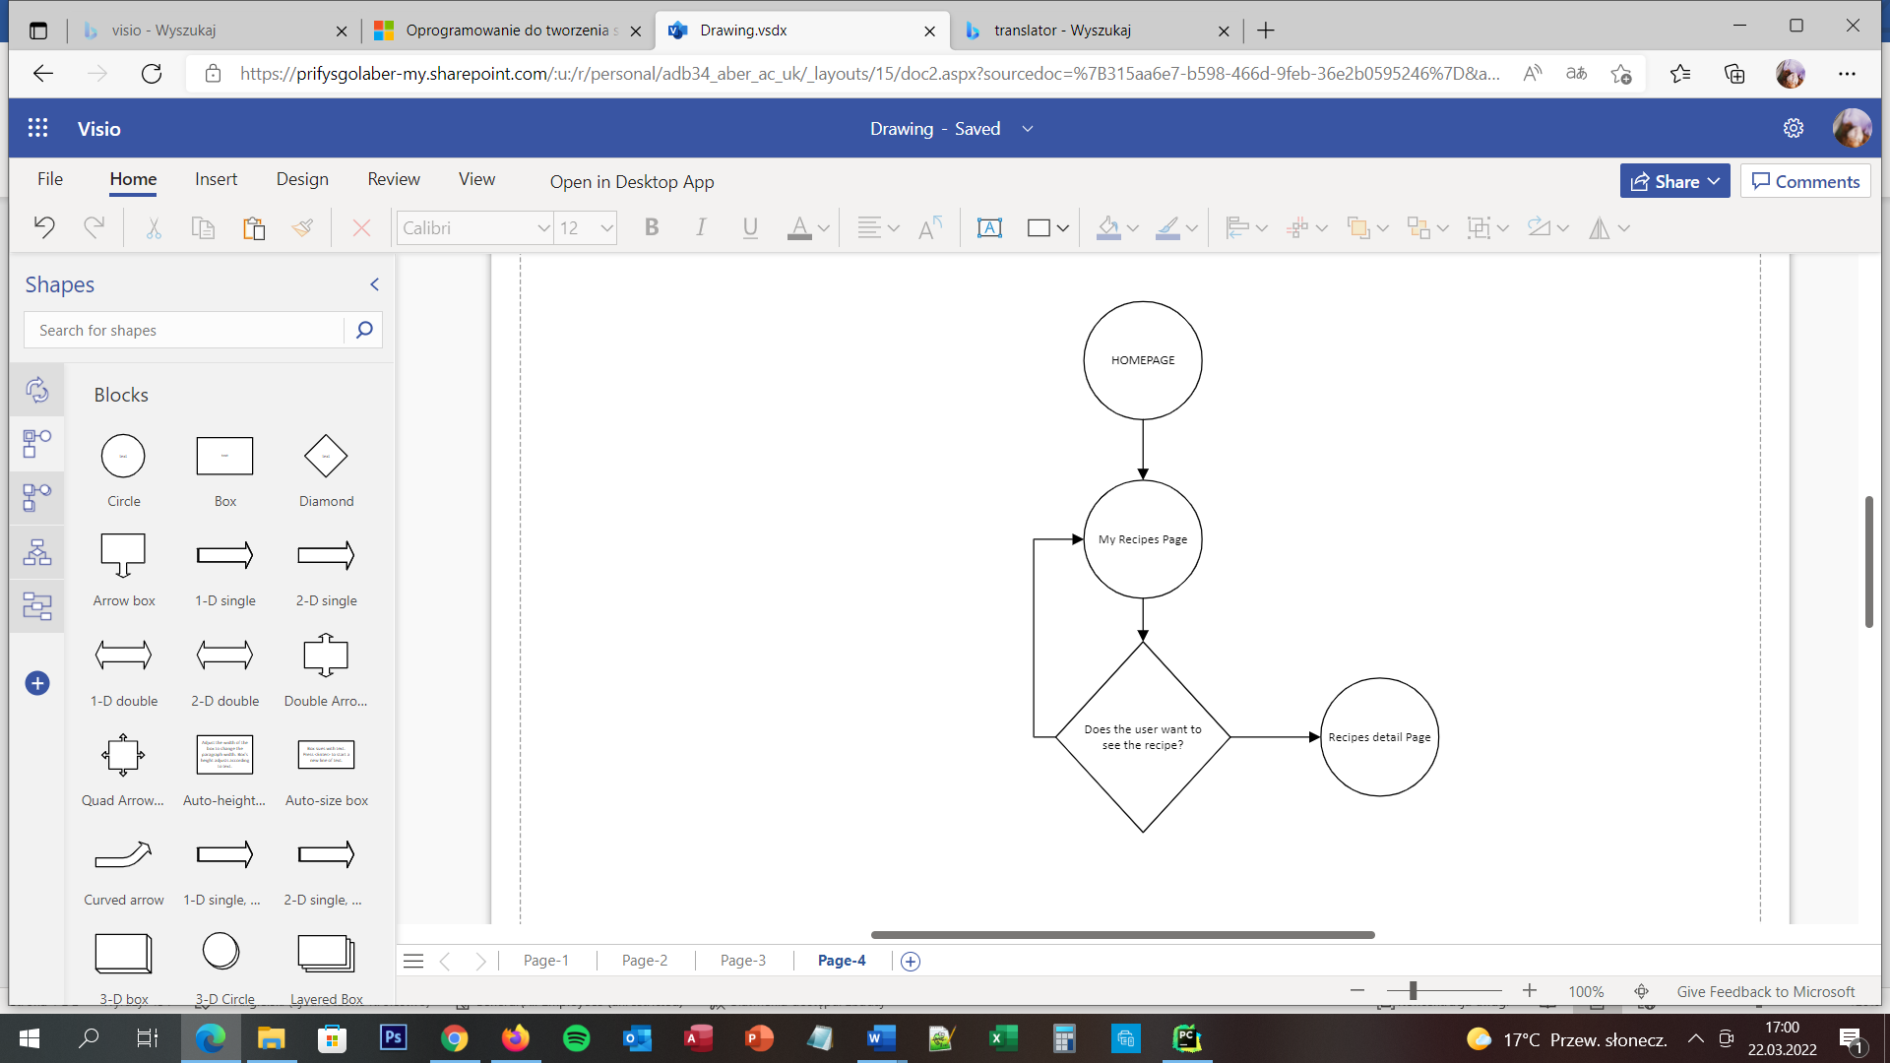

NO

YES

## User Story

User is able to view all of the recipes which he/she created by clicking the button – My Recipes – which is located on the top of the screen on navigation menu bar. On the screen is appear list of user recipes. If user wants to change them, delete them or view them user needs to clicked on the specific recipe and the he/she is moving to recipe detail page.

## Acceptance Criteria

The page should display list of recipes created by user and navigation menu bar. Each button should be clearly named. Seven of eight buttons should move user to connecting pages:

* Homepage to homepage
* About to about page
* New recipes to Add recipe page
* My recipes to my recipes page
* Profile should reload the page
* Logout to logout page

The tittle of each recipe should be a button which after user will clicked on this will be moving user to recipe detail page.

## User interface – Pseudo code

The My Recipes page is appear for the user when he/she is successfully log in to the website. On the client side is to press button My Recipes on the top screen navigation bar. On the server side is when user press this button – move him/her to My Recipes page. When the user will press any of the tittles to view details about the recipe – server needs to move user to the Recipes detail page.